Ticket cp: - Read the instructions carefully and then you start working on it



Ticket cp (Use cp command with various options for following tasks)

- Create a file1.txt with following text

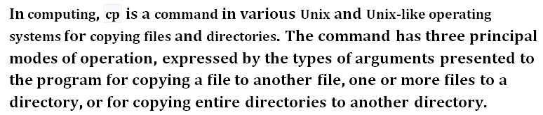

- Copy content of file1.txt to file2.txt
- Copy content of file2.txt to file3.txt, file4.txt and file5.txt all together in single command
- Create a directory name box1
- Copy file1.txt to box1
- Copy all remaining files to box1
- Create another directory box2
- Copy all files box1 to box2
- Copy box2 to box3, box4 and box5 all together in single command
- Create the backup of the destination file in the same folder with the different name and in different format.

